# Connecting Azure to Android Studio

## Steps I took to set up Azure Database to be accessible in Android Studio

1. I first ran the code under “Create a resource group and Azure Container Registry” in the *Deploy a containerized Flask or FastAPI web app on Azure App Service* document provided by Microsoft
   1. After I created a resource group, I then chose the free tier Linux plan for my app and created my app in Azure CLI
2. In my python backend folder, I used Azure CLI to add the files to Git, committed them, and then push them. Azure required me to provide a password that was set up for me when I created the web application in the CLI and I found it in the Azure Student’s *Deployment Center* under my web application (see below).

* 1. I ran the following commands (as shown below):
     1. git init
     2. git remote add azure [https://<username>@stockupapp.scm.azurewebsites.net/stockupapp.git](https://%3cusername%3e@stockupapp.scm.azurewebsites.net/stockupapp.git)
     3. git add .
     4. git commit -m “Initial Azure deploy”
     5. git push azure master
        1. Which I had to run several times because I made mistakes with the password

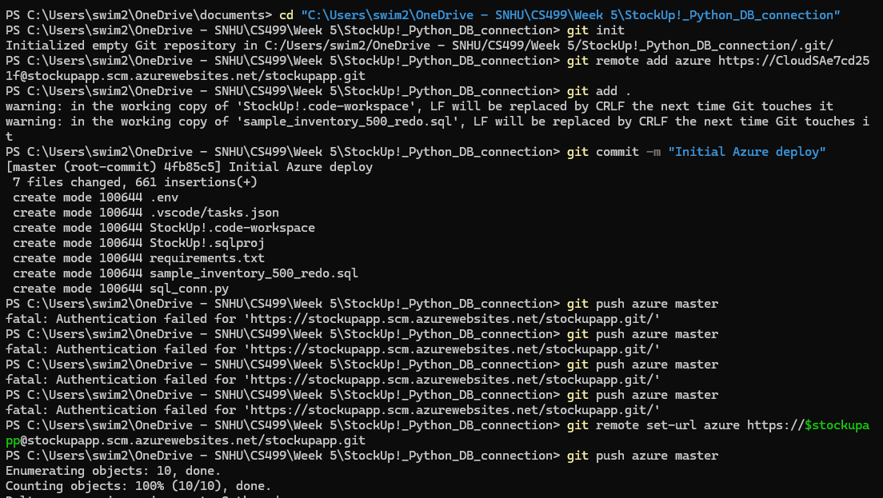

1. After everything was deployed successfully I added my backend endpoint into my ItemDatabase.java file to connect.

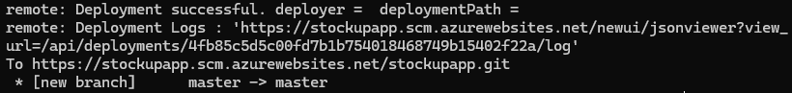

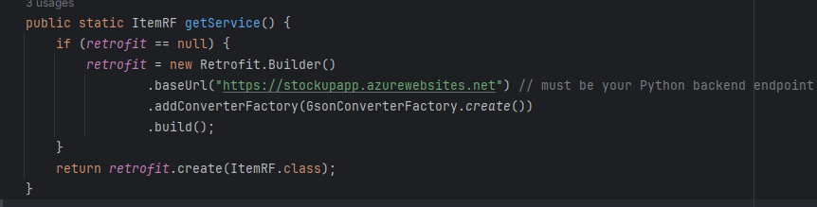

1. I also wanted to make sure that this endpoint was working, so I took an extra step to test it in Postman
   1. I had to run this code again by adding the statement “API is running” to make sure that the correct Python file was being used to deploy, rather than having to look through a bunch of HTML code I exchange it with this statement.

Resources

Simple web app tutorial - <https://learn.microsoft.com/en-us/azure/developer/python/tutorial-containerize-simple-web-app-for-app-service?tabs=web-app-flask>

FastAPI quick start - <https://learn.microsoft.com/en-us/azure/app-service/quickstart-python?tabs=flask%2Cwindows%2Cazure-cli%2Cazure-cli-deploy%2Cdeploy-instructions-azportal%2Cterminal-bash%2Cdeploy-instructions-zip-azcli>